Sales Analysis Project

“Data Cleaning with SQL & Visualization with Power BI”

***Prepared by:*** *Riddhi Gupta****Date:*** *August 2025*

Table of Contents

* *Introduction*
* *Data Cleaning and Preparation (SQL)*
* *Dashboard Overview (Power BI)*
* *Key Insights & Findings*
* *Recommendations / Solutions*
* *Conclusion*

Introduction

*The purpose of this project was to analyze sales performance from a company using* ***SQL*** *for data cleaning and insights generation, followed by* ***Power BI*** *for building an interactive dashboard.*

*This analysis focuses on:*

* *Identifying monthly sales trends*
* *Highlighting top customers and products*
* *Comparing revenue by country*
* *Measuring average order values*

*The final outcome provides a* ***data-driven understanding*** *of sales and offers recommendations for improving company’s performance.*

Data Cleaning and Preparation

*The raw dataset contained sales data with inconsistencies such as missing values, duplicates, and formatting issues, which was processed and transformed using* ***SQL*** *to ensure accuracy and reliability of the analysis.*

*Steps performed in SQL:*

* ***Data Quality Checks:***
* *Identified and removed duplicate rows.*
* *Handled missing or null values in key fields (e.g., Quantity, Price, InvoiceDate).*
* ***Data Formatting and Standardization:***
* *Converted InvoiceDate into a consistent* ***Year-Month format***
* *Standardized numeric fields such as Quantity and Price to ensure proper calculations.*
* ***Derived Metrics Creation and Business-Oriented Tables:***
* *Built aggregated views for:*
  + ***Monthly Revenue***
  + ***Top Customers by Revenue***
  + ***Top Products by Sales***
  + ***Country-wise Sales Distribution***
* *Designed query outputs that directly fed into Power BI, making the visualization layer more efficient.*
* *Example queries included:*
  + *Monthly sales summary*
  + *Customer contribution ranking*
  + *Revenue by product categories*

***Outcome:*** *The SQL cleaning and transformation ensured that the dataset was* ***error-free, structured, and business-ready****, forming a reliable foundation for visualization and insights generation in Power BI.*

*Few data cleaning queries :*

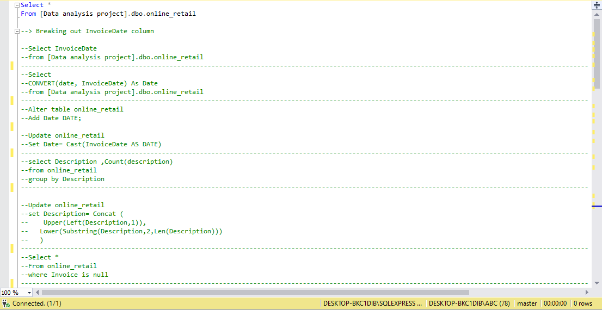

*Few Insight queries :*

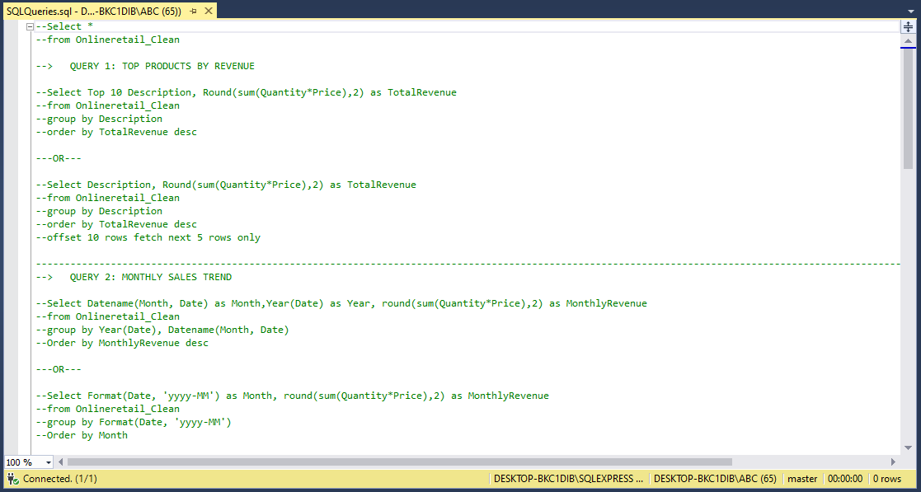

Dashboard Overview

*Using Power BI, a* ***Sales Performance Dashboard*** *was created to visualize key metrics.*

*Dashboard features:*

* ***Monthly Sales Trend:*** *Shows revenue performance month by month.*
* ***Top 10 Customers:*** *Highlights the customers contributing the most to revenue.*
* ***Top 5 Products:*** *Identifies the highest-selling products.*
* ***Revenue by Country:*** *Compares total sales across different countries.*
* ***Average Order Value (Monthly & Yearly):*** *Measures spending patterns.*

* 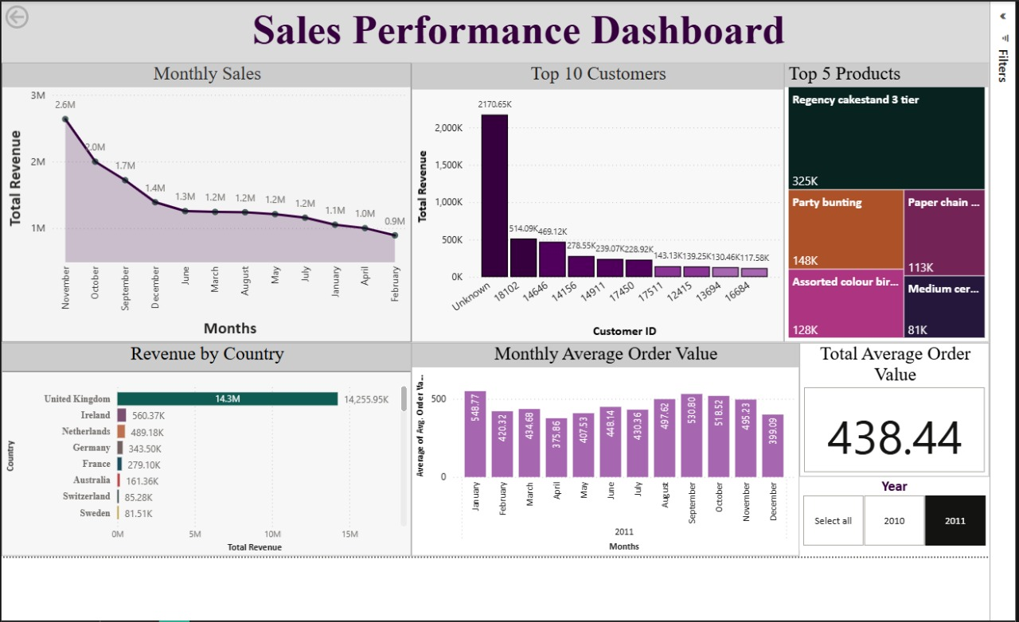

*Sales Performance Dashboard*

Insights & Findings

*From the dashboard analysis, the following insights were derived:*

* ***Monthly Sales Trends:***
  + *Peak sales occurred in* ***November (2.6M revenue)****.*
  + *Sales gradually declined from December to February.*
* ***Top Customers:***
  + *A customer with unknown ID contributed the highest revenue, 2170.65K followed by customer 18102 ranking 2nd in this section with revenue of 514.09K.*
  + *A small number of customers contribute disproportionately to sales.*
* ***Top Products:***
  + ***“Regency Cakestand 3 Tier”*** *generated the highest product revenue.*
  + *Seasonal and decorative products like “Party Bunting” also performed well.*
* ***Revenue by Country:***
  + *The* ***United Kingdom dominates sales*** *with over 14.3M revenue.*
  + *Other countries (Ireland, Netherlands, Germany and more) contribute significantly less.*
* ***Average Order Value:***
  + *The overall* ***average order value is 438.44****.*
  + *Strong months: January (548.77).*
  + *Weak months: December (399.09).*

Recommendations

*Based on the findings, the following actions are suggested:*

* ***Leverage Seasonal Sales Peaks:***
  + *Since November recorded the highest sales, the company should intensify* ***holiday campaigns and discounts*** *around October–December..*
* ***Customer Retention Programs:***
  + *High-value customers should be rewarded with* ***exclusive discounts, loyalty programs, or personalized offers****.*
* ***Geographical Expansion:***
  + *With 14M revenue, the UK dominates sales. However, markets like Ireland and the Netherlands show potential. Increasing* ***localized marketing*** *in these regions can drive growth.*
* ***Product Strategy:***
  + *Ensure consistent stock and introduce* ***bundled deals*** *for bestsellers like* Regency Cakestand 3 Tier*.*
  + *Explore expanding product variations (colors, sizes) and introducing premium versions.*
* ***Stabilize Order Values:***
  + *Average order value is 438.44, but months like December show a dip. Offering* ***“buy more, save more” discounts*** *during low months can stabilize sales.*

Conclusion

*This project highlights how* ***SQL and Power BI*** *can be used together to transform raw sales data into meaningful insights.*

*The dashboard provides visibility into:*

* *Sales trends*
* *Customer contribution*
* *Product performance*
* *Regional distribution*
* *Order value behavior*

*With the implementation of the solutions mentioned earlier, the company can* ***increase revenue, improve customer loyalty, and optimize product strategies****.*